BIOLOGY DEPT
NAMUNGOONA SALAF S.S
ECOLOGY TEST 1
08th june 2020

SECTION B
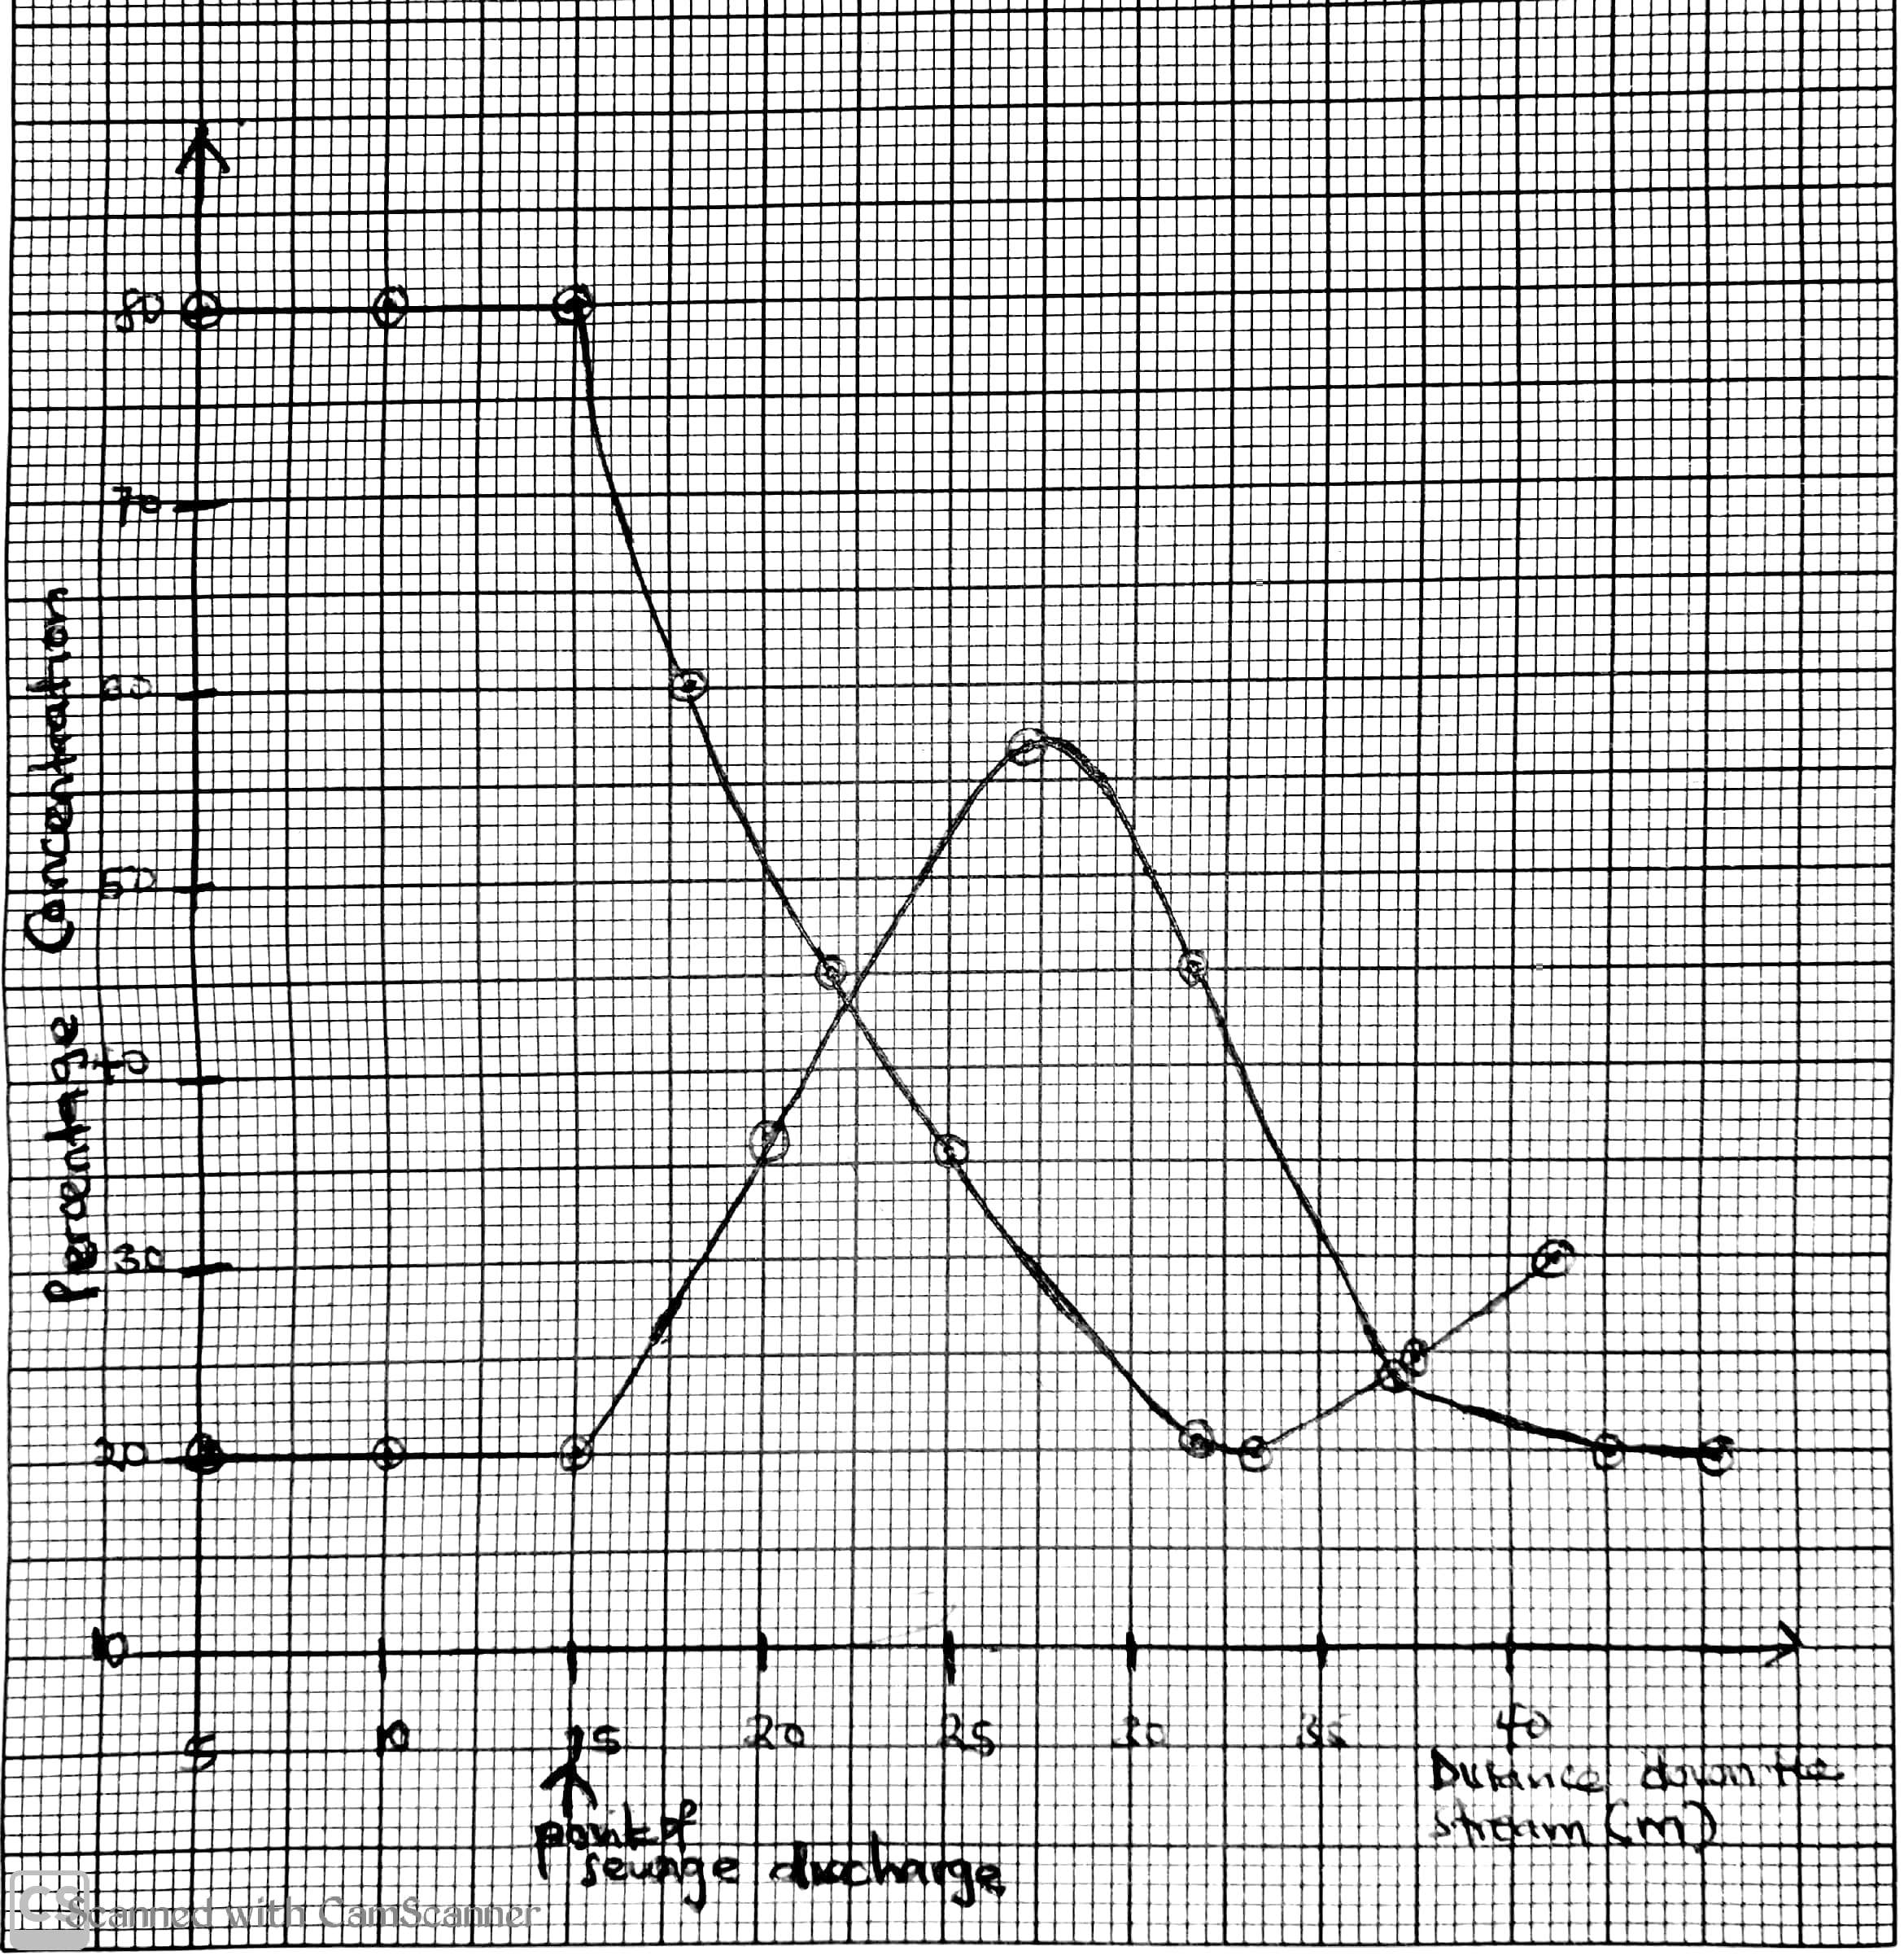
1.The graph below shows the percentage change in the concentration of ammonium ions and dissolved oxygen down the stream of a river before and after sewage was discharged into water

Dissolved oxygen

Ammonium ions

a) Describe the changes in the percentage concentration of ammonium ions (03mrks)
................................................................................................................................
................................................................................................................................
................................................................................................................................
................................................................................................................................
b) Compare the percentage concentration of ammonium ions and dissolved oxygen (03mrks)
................................................................................................................................
................................................................................................................................
................................................................................................................................
................................................................................................................................
c) Explain the changes in the percentage concentration of ammonia and dissolved oxygen between
i) 15m to 30m
Ammonium ions (02mrks)
................................................................................................................................
................................................................................................................................
................................................................................................................................
Dissolved oxygen (02mrks)
................................................................................................................................
................................................................................................................................
...............................................................................................................................
ii) 35m to 40m
Ammonium ions (02mrks)
................................................................................................................................
................................................................................................................................
...............................................................................................................................
Dissolved oxygen (02mrks)
................................................................................................................................
................................................................................................................................
................................................................................................................................
d) Suggest how the following are affected by pouring sewage into the river
i) Population of fish (02mrks)
................................................................................................................................
................................................................................................................................
ii) Population of anerobic bacteria (02mrks)
................................................................................................................................
................................................................................................................................
e) Suggest and explain two physical indicators of water quality that can be monitored in the river (02marks)
................................................................................................................................
................................................................................................................................
2. A group of students from Namungoona salaf SS did an investigation about some organisms present in a grassland and the flow of energy through the
web. The table below shows the results of their findings.

Feeding level | Name of organism | Number of organism | Energy flow through the food web (KJ)
X | Grass | 300,000 | 20000
Y | Grasshoppers | 25600 | 1353
Y | Sead eating birds | 45 | 2567
Y | Field mouse | 42 | 1941
Z | kestrel ( bird of prey) | 2 | 412

ai) Calculate the percentage of energy which passes from feeding level X to Y (02mrks)
................................................................................................................................
................................................................................................................................
................................................................................................................................
................................................................................................................................
ii) State two ways in which energy can be lost from the food chain (02mrks)
................................................................................................................................
................................................................................................................................
bi) Identify the feeding levels indicated as X,Y and Z(1½mrks)
X............................................................................
Y........................................................................
Z......................................................................
ii) Using a food chain consisting of grass ,grasshoppers and kestrel, construct a pyramid of biomass
................................................................................................................................
................................................................................................................................
................................................................................................................................
................................................................................................................................

c) Grasses can be sprayed with a pesticide which kills a large number of grasshopper.Explain how this activity affects other organisms within the food chain
................................................................................................................................
................................................................................................................................
................................................................................................................................
3. An owl in the sky can hunt and feed on a mouse at night
a) State the feeding relationship between a mouse and an owl (01mrk)
................................................................................................................................
................................................................................................................................
b) State any 3 adaptations of
i) An owl to successfully feed on the mouse (03mrks)
................................................................................................................................
................................................................................................................................
................................................................................................................................
................................................................................................................................
ii) A mouse to successfully escapee from the owl(03mrks)

................................................................................................................................
................................................................................................................................
................................................................................................................................
................................................................................................................................
c) If a mouse feeds on maize grains and its also fed on by a snake
i) Draw a food chain to show the flow of energy between the 3 organism (01mrk)
................................................................................................................................
................................................................................................................................
ii) Explain what will happen to the food chain when the owls are removed from the habitat (02mrks)
................................................................................................................................
................................................................................................................................
SECTION C

Each question carries 15marks
4a) What is meant by the biomass
b) Describe how you would determine the population of the following
i) grass hoppers in their habitats
ii) Elephant in zoo
ii) wondering jaw
5a) Distinguish between population and a community
b) Describe the factors that affect the population of zebra in a game park
6.Describe the causes, effects and control of water pollution

